**Content**

1. Nadpis 1 3

1. Dynamo DB

API – no servers, serverless architecture. Build as a fault tolerant highly available service. On the back end, it fully synchroniuzes the data across all of the availability zones within the region you created the DynamoDB tables in.

* ITO (storing metadata)
* Gaming (storing session info, leaderborads)
* Mobile (storing user profiles, personalization)

Built on top of SSD + parallelism.

* Partition key (if it was no unique i need to add sort key.

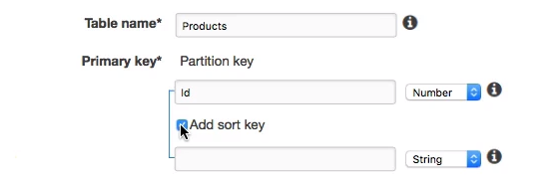

* Sort key
* Composite key

Default settings – 5 reads/s and 5 writes/s. You can set higher, or leave 5-5 but allow autoscaling (needs role). Items dont have to hafve the same attributes. You can add book and bicycles to the product table too.

* Scan
* Query

1. ElastiCache

Used to offload other databases, so you are not loading them w the same query statements again and again. Good for sessions.

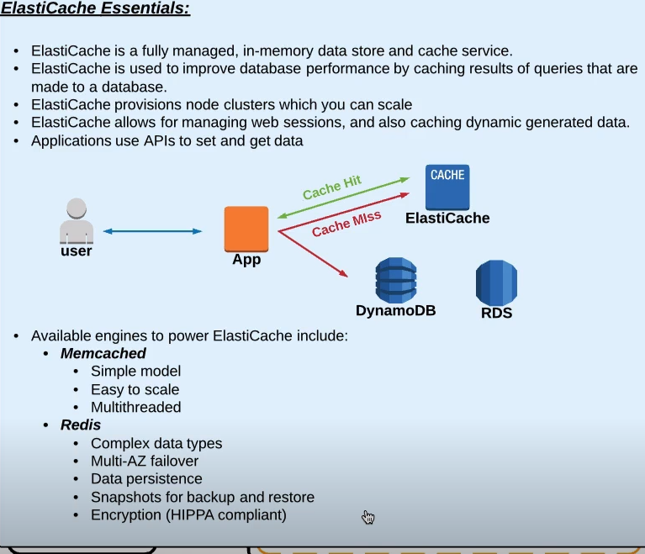

1. Redshift

Optimized for analytics. Large, systems feed them. Validation, cleaning up the data. Reports.

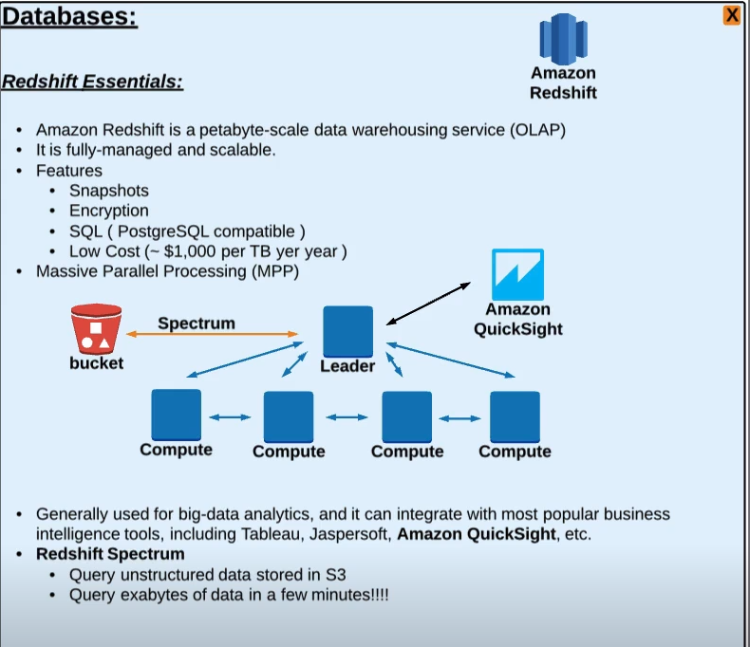

You can connect to the leader w sql client. It passes the work to compute nodes. You can use any postgres compatible tool. QuickSight – visual reports of the queries.

Spectrum – extend quetries , add unstructured data stored on s3.

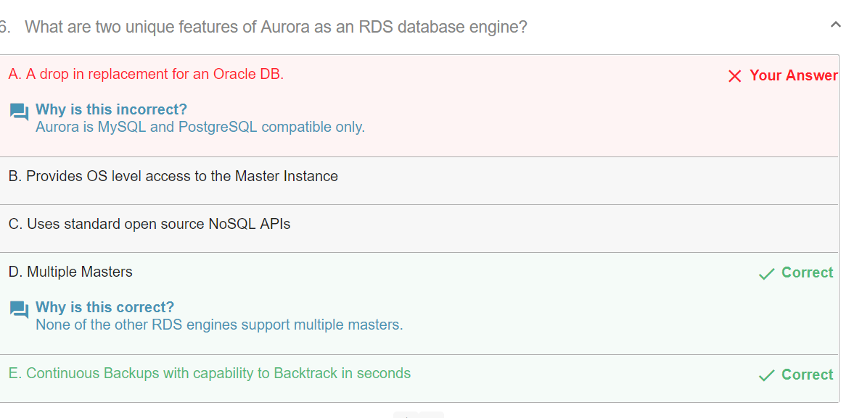

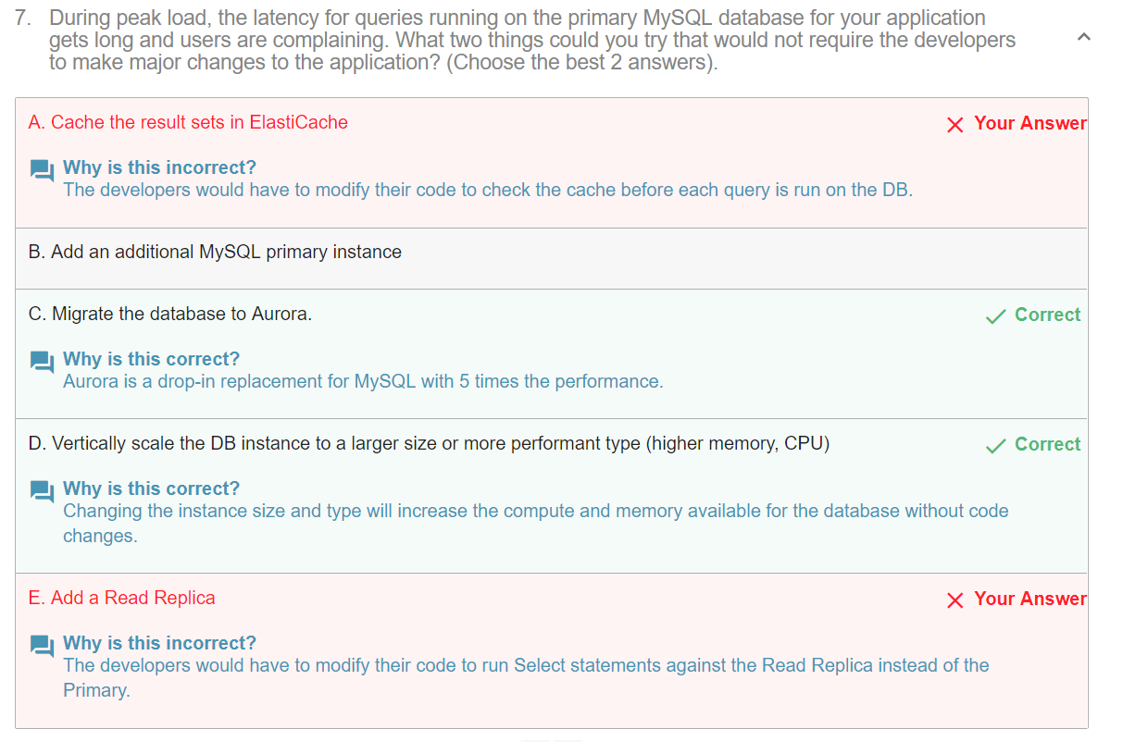

CF – accelerate delivery by caching content on locations closer to the enduser. (Edge locations) Caches static content for website, so origins are offloaded from extra traffic. Data transfer from s3 to cloudfront is free. Live video streaming and VOD or web distribution. Cloudfront.net domain name by default, you can use HTTPS by default. GET ofc, but you can use POST/PUT too – long connections may not be that stable. TTL – how long are objects cached for. If you need to change the cache – rename the logo for logo2 or invalidate – costly.

RTMP distribution – you must store the media files in an S3 bucket, use CF live streaming, create web distribution.

* AWS Shield
* AWS WAF

Signed URL or Signed Cookie (expiration, restrict by IP ..)

Dynamic objects are still cached, connection optimization.

Launch Configuration vs Launch Template (new) Launch templates give you the option of launching one type of instance, or a combination of instance types and purchase options. Launch templates include the latest Amazon EC2 features and can be updated and versioned.

1. S3

Backups, replicating objects

File shared and backups/archiving for hybrid networks (via AWS Storage Gateway)

You should always create an S# bucket in a region that makes sense to it’s purpose, serving content to customers, sharing data with ec2.

All regions support:

* Red-after-write consistency for PUTS of new objects
* Eventual consistency for PUTS overwriting existing objects and DELETES of objects

In theoretical computer science, the CAP theorem, also named Brewer's theorem after computer scientist Eric Brewer, states that it is impossible for a distributed data store to simultaneously provide more than two out of the following three guarantees:

* Consistency: Every read receives the most recent write or an error
* Availability: Every request receives a (non-error) response – without the guarantee that it contains the most recent write
* Partition tolerance: The system continues to operate despite an arbitrary number of messages being dropped (or delayed) by the network between nodes